Delete Controller/ Action (function)

Table name: language_routes

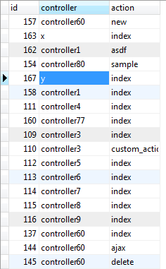

The first interface is designed with a dropdown that is labeled with “Controller” . Controllers might contain multiple actions. That is why a button “Delete Action” is provided. After choosing a controller to be deleted, you need to click the delete action button. Upon clicking the delete action button, a query is executed. This query looks for the action where it has the same id of the chosen controller.

This is the interface in deleting the Controller or action

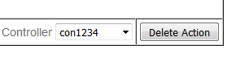

1. Dropdown field 2. Button

->Dropdown that contains ->This button will redirect to the next page

The controller’s name from the database

After Clicking the “Delete Action button” this page will be displayed.

The action dropdown contains only the actions that have the same id from the chosen controller.

deleteUi2.png

Delete

Dropdown -> contains the actions

from the database